Maxi

Claudia Falsetti

17 February 2018

## R Markdown

This is an R Markdown document. Markdown is a formatting syntax for authoring HTML, PDF, and MS Word documents. For more details on using R Markdown see <http://rmarkdown.rstudio.com>.

When you click the **Knit** button a document will be generated that includes both content as well as the output of any embedded R code chunks within the document.

** Data Analysis **

Firstly, I set the working directory to point at the folder in which I saved the results.csv files and load the libraries that will be needed throughout the code.

## ── Attaching packages ─────────────────────────────────────────────────────────────────────────────────────────────── tidyverse 1.2.1 ──

## ✔ ggplot2 2.2.1 ✔ purrr 0.2.4  
## ✔ tibble 1.3.4 ✔ dplyr 0.7.4  
## ✔ tidyr 0.7.2 ✔ stringr 1.2.0  
## ✔ readr 1.1.1 ✔ forcats 0.2.0

## ── Conflicts ────────────────────────────────────────────────────────────────────────────────────────────────── tidyverse_conflicts() ──  
## ✖ dplyr::filter() masks stats::filter()  
## ✖ dplyr::lag() masks stats::lag()

## Loading required package: Matrix

##   
## Attaching package: 'Matrix'

## The following object is masked from 'package:tidyr':  
##   
## expand

Now the .csv files are loaded in as a list and imported within the same dataframe named data_frame.

results = list.files(pattern = ".csv")  
data = lapply(results, read.csv, header = FALSE, stringsAsFactors = FALSE)  
data_frame <- do.call("rbind", data)

**Data preprocessing**

I eliminated unneeded columnes and rows and prepared the data for descriptive investigation and statistical analysis

data_frame <- data_frame[-1: -2, ] %>% ## remove first 2 rows (completion code)   
 select(V2, V7, V27, V28, V29, V33, V34) ## and select relevant columns  
  
colnames(data_frame) <- data_frame[1,] ####### set the first row to be the header of the data frame   
final_data <- data_frame[-1, ]   
  
final_data <- filter(final_data, trialNo != "na", trialNo != "", trialNo != "trialNo")   
  
final_data <- final_data %>% # add a column for sujb_id, 275 represents n° of trials per participant  
 mutate("subj_id" = rep(1:31,each=275)) ### change 5 with actual number of participants

**Descriptives.**

Before proceding to the analysis, the dataset is explored. This includes measures of means, standard deviations and plots. A new dataframe called Ultimatum is created. It only includes results relative to the ultimatum game. The response to the ultimatum game is recoded as accepted = 1, rejected = 0. The descriptive statistics for the ultimatum game are summarised in the data_frame called ultim_summary and are visualised with a bar plot. The offers are coded as:

* 1: 90/10
* 2: 75/25
* 3: 60/40

final_data$RT <- as.numeric(final_data$RT) ### set some variables to be as.numeric for future things  
final_data$response <- as.numeric(final_data$response)  
  
ultimatum <- final_data %>% ## create a dataframe with only UltimatumGame results   
 group_by(subj_id) %>% #### recode response as acceptance -> accepted=1, rejected = 0  
 filter(game == "ultimatum") %>%   
 mutate(acceptance = if_else(response == 1, 0L, 1L)) %>%   
 mutate(RT_S = RT / 1000) %>%  
 select(subj_id, everything())   
  
ultim_summary <- ultimatum %>% #### descriptive statistics   
 group_by(stim_type, offer) %>%  
 summarise(p = mean(acceptance),  
 sd = sd(acceptance))  
  
accepted_only <- ultimatum %>%  
 filter(acceptance == 1) %>%  
 group_by(offer) %>%  
 count(acceptance) %>%  
 mutate(perc = n/2325*100)  
  
accepted_stim <- ultimatum %>%  
 filter(acceptance == 1) %>%  
 group_by(stim_type)%>%  
 summarise(mean = mean(acceptance), SD = sd(acceptance))  
  
accepted_only_2 <- ultimatum %>%  
filter(acceptance == 1) %>%  
group_by(offer, stim_type) %>%  
count(acceptance)  
  
  
united <- full_join(accepted_only, accepted_only_2, by = "offer") %>%  
 select(offer, stim_type, n.x, perc, n.y) %>%  
 group_by(offer, stim_type)  
  
acceptance_rates <- vector("numeric", length = length(united$n.y))  
  
for (i in 1:length(united$n.y)) {  
 count <- (united[i, "n.y"])  
 tot <- (united [i, "n.x"])  
   
   
 acceptance_rates[i] <- count/tot*100  
   
 }  
  
rates <- do.call(rbind.data.frame, acceptance_rates)  
colnames(rates) <- "acceptance_rates"  
  
united["acceptance_rates"] <- rates$acceptance_rates  
  
  
acceptance_overall <- ggplot(accepted_only, aes(x = offer, y = perc, fill = offer)) + geom_col() + coord_cartesian(ylim = c(0,100))  
   
  
acceptance_stim <- ggplot(united, aes(x = stim_type, y = acceptance_rates, fill = stim_type)) + geom_col() +  
 facet_grid(~offer)   
  
col_plot <- ggplot(ultim_summary, aes(x = stim_type, y = p, fill = stim_type)) + geom_col() +  
 facet_grid(~offer)

Preparing the data for the analysis : **recoding** .

Due to the binary nature of the dependent variable and its binomial distribution, a mixed effects model was used to analyse the data. In the model, the acceptance to the ultimatum game was the response variable and offer and stimulus type were the predictors.

###### re- coding   
  
ultimatum_dev <- ultimatum %>%  
 mutate(offer_1 = ifelse(offer == "1", .5, -.5),  
 offer_2 = ifelse(offer == "2", .5, -.5),  
 brand = ifelse(stim_type == "brand", .5, -.5),  
 human = ifelse(stim_type == "human", .5, -5))  
  
  
model <- glmer(acceptance ~ (offer_1 + offer_2) * (brand + human) + ( (offer_1 + offer_2) * (brand + human)||subj_id), ultimatum_dev, binomial, control=glmerControl(optimizer="bobyqa", optCtrl= list(maxfun=100000)))  
  
summary(model)

## Generalized linear mixed model fit by maximum likelihood (Laplace  
## Approximation) [glmerMod]  
## Family: binomial ( logit )  
## Formula: acceptance ~ (offer_1 + offer_2) * (brand + human) + ((offer_1 +   
## offer_2) * (brand + human) || subj_id)  
## Data: ultimatum_dev  
## Control:   
## glmerControl(optimizer = "bobyqa", optCtrl = list(maxfun = 1e+05))  
##   
## AIC BIC logLik deviance df.resid   
## 3932.5 4055.8 -1948.2 3896.5 6957   
##   
## Scaled residuals:   
## Min 1Q Median 3Q Max   
## -28.0713 -0.1910 0.0440 0.2081 11.6219   
##   
## Random effects:  
## Groups Name Variance Std.Dev.  
## subj_id (Intercept) 7.01368 2.6483   
## subj_id.1 offer_1 8.12888 2.8511   
## subj_id.2 offer_2 5.34393 2.3117   
## subj_id.3 brand 4.03960 2.0099   
## subj_id.4 human 0.09862 0.3140   
## subj_id.5 offer_1:brand 0.34552 0.5878   
## subj_id.6 offer_1:human 0.00000 0.0000   
## subj_id.7 offer_2:brand 0.00000 0.0000   
## subj_id.8 offer_2:human 0.00000 0.0000   
## Number of obs: 6975, groups: subj_id, 31  
##   
## Fixed effects:  
## Estimate Std. Error z value Pr(>|z|)   
## (Intercept) -1.91623 0.50060 -3.828 0.000129 ***  
## offer_1 -8.02295 0.65667 -12.218 < 2e-16 ***  
## offer_2 -4.41755 0.52798 -8.367 < 2e-16 ***  
## brand -0.90285 0.40031 -2.255 0.024109 *   
## human -0.23966 0.06408 -3.740 0.000184 ***  
## offer_1:brand -1.07763 0.43526 -2.476 0.013293 *   
## offer_1:human -0.15770 0.06943 -2.271 0.023118 *   
## offer_2:brand -0.84143 0.34971 -2.406 0.016123 *   
## offer_2:human -0.12795 0.06080 -2.105 0.035330 *   
## ---  
## Signif. codes: 0 '***' 0.001 '**' 0.01 '*' 0.05 '.' 0.1 ' ' 1  
##   
## Correlation of Fixed Effects:  
## (Intr) offr_1 offr_2 brand human offr_1:b offr_1:h offr_2:b  
## offer_1 0.107   
## offer_2 0.054 0.259   
## brand 0.065 0.056 0.046   
## human 0.102 0.098 0.053 0.090   
## offr_1:brnd 0.060 0.286 0.208 0.177 0.061   
## offer_1:hmn 0.104 0.384 0.257 0.061 0.194 0.458   
## offr_2:brnd 0.051 0.207 0.334 0.138 0.080 0.620 0.348   
## offer_2:hmn 0.052 0.232 0.402 0.077 0.125 0.331 0.625 0.563

##likelihood ratio tests   
  
mod2 <- update(model, . ~ . -offer_1 -offer_2)  
anova(model, mod2) # test main effect of type of offer

## Data: ultimatum_dev  
## Models:  
## mod2: acceptance ~ brand + human + ((offer_1 + offer_2) * (brand +   
## mod2: human) || subj_id) + offer_1:brand + offer_1:human + offer_2:brand +   
## mod2: offer_2:human  
## model: acceptance ~ (offer_1 + offer_2) * (brand + human) + ((offer_1 +   
## model: offer_2) * (brand + human) || subj_id)  
## Df AIC BIC logLik deviance Chisq Chi Df Pr(>Chisq)   
## mod2 16 4031.0 4140.6 -1999.5 3999.0   
## model 18 3932.5 4055.8 -1948.2 3896.5 102.57 2 < 2.2e-16 ***  
## ---  
## Signif. codes: 0 '***' 0.001 '**' 0.01 '*' 0.05 '.' 0.1 ' ' 1

mod3 <- update(model, . ~ . -brand - human)  
anova(model, mod3) # test main effect of source (stim_type)

## Data: ultimatum_dev  
## Models:  
## mod3: acceptance ~ offer_1 + offer_2 + ((offer_1 + offer_2) * (brand +   
## mod3: human) || subj_id) + offer_1:brand + offer_1:human + offer_2:brand +   
## mod3: offer_2:human  
## model: acceptance ~ (offer_1 + offer_2) * (brand + human) + ((offer_1 +   
## model: offer_2) * (brand + human) || subj_id)  
## Df AIC BIC logLik deviance Chisq Chi Df Pr(>Chisq)   
## mod3 16 3944.2 4053.8 -1956.1 3912.2   
## model 18 3932.5 4055.8 -1948.2 3896.5 15.761 2 0.0003781 ***  
## ---  
## Signif. codes: 0 '***' 0.001 '**' 0.01 '*' 0.05 '.' 0.1 ' ' 1

mod4 <- update(model, . ~ . -offer_1:brand - offer_1:human - offer_2:brand - offer_2:human)  
anova(model, mod4) # test interaction

## Data: ultimatum_dev  
## Models:  
## mod4: acceptance ~ offer_1 + offer_2 + brand + human + ((offer_1 +   
## mod4: offer_2) * (brand + human) || subj_id)  
## model: acceptance ~ (offer_1 + offer_2) * (brand + human) + ((offer_1 +   
## model: offer_2) * (brand + human) || subj_id)  
## Df AIC BIC logLik deviance Chisq Chi Df Pr(>Chisq)   
## mod4 14 3933.0 4028.9 -1952.5 3905.0   
## model 18 3932.5 4055.8 -1948.2 3896.5 8.5535 4 0.07328 .  
## ---  
## Signif. codes: 0 '***' 0.001 '**' 0.01 '*' 0.05 '.' 0.1 ' ' 1

As expected, there was a main effect of offer type such that participants accepted the £40 offer 35% more often than the 25£ offer and 72% more often than the £10 offer: $χ^{2}(2)$ = 102.57, p < .001

Means and standard deviations for each offer can be viewed in the table below. Offer 1 is the £10 offer, 2 is £25 and 3 is £40.

accepted_offer <- accepted_only %>%  
 select(offer, perc) %>%  
 print()

## # A tibble: 3 x 2  
## # Groups: offer [3]  
## offer perc  
## <chr> <dbl>  
## 1 1 20.25806  
## 2 2 57.29032  
## 3 3 92.90323

Moreover, the analysis revealed a significant main effect of the source (stim_type). As expected, unfair offers (£10) from the computer were accepted on average more often as compared to the same offers proposed by brands and humans : $χ^{2}(2)$ = 15.761, p < .001

However, testing the interaction between offer type and proposer did not yielded significant results, $χ^{2}(4)$ = 8.55, p = .073. This is attributable to the fact that the main effect of the source was observable only on one level of the offer type, namely the £10 offer (offer1). This is easily visualised in the bar chart below.

print(col_plot)

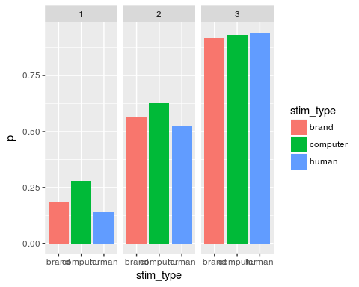

Code for the ANOVA, with the same variables

ultim_summary <- ultimatum %>%  
 group_by(subj_id, stim_type, offer) %>%  
 summarise(p = mean(acceptance), sd = sd(acceptance))   
  
anova <- with(ultim_summary,  
 aov(p ~ offer * stim_type +  
 Error(subj_id / (offer * stim_type)))  
)  
  
summary(anova)

##   
## Error: subj_id  
## Df Sum Sq Mean Sq F value Pr(>F)  
## Residuals 1 0.09613 0.09613   
##   
## Error: subj_id:offer  
## Df Sum Sq Mean Sq  
## offer 2 19.55 9.777  
##   
## Error: subj_id:stim_type  
## Df Sum Sq Mean Sq  
## stim_type 2 0.3721 0.186  
##   
## Error: subj_id:offer:stim_type  
## Df Sum Sq Mean Sq  
## offer:stim_type 4 0.1661 0.04153  
##   
## Error: Within  
## Df Sum Sq Mean Sq F value Pr(>F)   
## offer 2 5.060 2.5298 29.027 4.14e-12 ***  
## stim_type 2 0.013 0.0067 0.076 0.926   
## offer:stim_type 4 0.114 0.0285 0.327 0.859   
## Residuals 261 22.748 0.0872   
## ---  
## Signif. codes: 0 '***' 0.001 '**' 0.01 '*' 0.05 '.' 0.1 ' ' 1

**Ratings of Trustworthiness**

Working with the ratings of trustworthiness. Below, I created a dataframe with the trustworthiness ratings only. Ratings of trustworthiness are grouped into categories:

* rating1 = [0,10,20,30]
* rating2 = [4,50,60]
* rating3 = [70,80,90,100]

### recoding of variabels, binning the trustworthiness ratings into 3 categories.   
  
trust <- final_data %>%  
 group_by(subj_id) %>%  
 filter(game == "trust") %>%  
 mutate(rating_binned = ifelse(response <=4, 1,  
 ifelse(response %in% 5:7, 2,  
 ifelse(response >= 8, 3, 0)))) %>%  
 mutate(rating1 = ifelse(response <= 4, .5, -.5 ),  
 rating2 = ifelse(response == 7 | response == 6| response ==5, .5, -.5), rating3 = ifelse(response >= 8, .5,-.5))

Now I created a merged data_frame including ratings of trustworthiness and ultimatum responses. In order to analyse the effect of brand and human only and account for the ratings of trustworthiness, the ultimatum game responses relative to computer offers were dropped from the following computations.

ultimatum_no_computer <- ultimatum %>%  
 filter(stim_type != "computer") %>%  
 select(stim_type, stim1, subj_id, acceptance, offer)  
  
rating <- trust %>%  
 group_by(stim1) %>%  
select(rating_binned, subj_id, stim1, stim_type)  
  
rating_mod <- trust %>%  
 group_by(stim1) %>%  
 select(rating1, rating2, rating3, stim1, subj_id, stim_type)  
  
joined_mod <- merge(rating_mod, ultimatum_no_computer)  
  
rat_mod_2 <- joined_mod %>%  
 filter(offer < 3) %>%  
 mutate(offer1 = ifelse(offer==1, .5, -.5),  
 stim_type_b = ifelse(stim_type == "brand", .5, -.5)) %>%  
 select(stim1, subj_id, stim_type_b, offer1, rating1, rating3, acceptance)  
  
joined <- merge(rating, ultimatum_no_computer)  
  
join_summary <- joined %>%  
 group_by(rating_binned, stim_type, offer) %>%  
 summarise(p = mean(acceptance))  
  
join2 <- joined %>%  
 group_by(rating_binned, stim_type) %>%  
 summarise(p = mean(acceptance))  
  
  
plot2 <- ggplot(join2, aes(rating_binned, p, colour=stim_type)) +   
 geom_line() + geom_point() + coord_cartesian(ylim = c(0, 1)) +  
 labs(y = "probability")   
  
print(plot2)

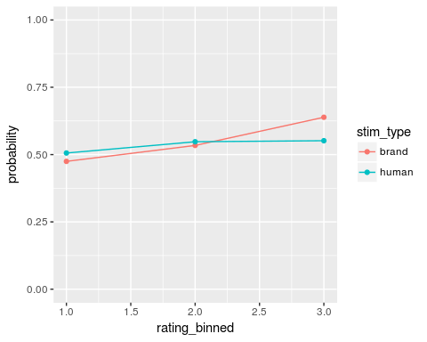

From the graph above it is possible to notice that at equal ratings of trustworthiness, participants accepted offers from brands and humans in a slight yet dissimilar way. Specifically, higher ratings of trustworthiness seemed to affect only acceptance of brands offer, which slightly increased.

In order to visualise the relationship in a more detailed manner, I added the different offer to the plot.

plot <- ggplot(join_summary, aes(rating_binned, p, colour=stim_type)) +   
 geom_line() + geom_point() + coord_cartesian(ylim = c(0, 1)) +  
 labs(y = "probability") + facet_grid(~offer)  
print(plot)

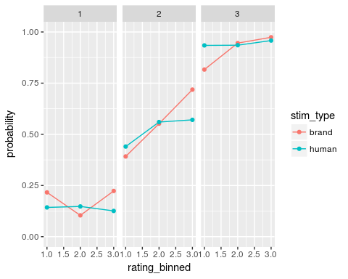

Althought no clear pattern or relationship seem to emerge from the graph, it is still noticeable that perceived trust has a bigger effect on acceptance of offers from brands as compared to offers from humans.

As the table and bar chart below show, differences in acceptance rates between brands and human offers were higher in the highest rating categories (rating3) and showed a preference to accept offers proposed by brands.

print(join2)

## # A tibble: 6 x 3  
## # Groups: rating_binned [?]  
## rating_binned stim_type p  
## <dbl> <chr> <dbl>  
## 1 1 brand 0.4748299  
## 2 1 human 0.5057915  
## 3 2 brand 0.5339367  
## 4 2 human 0.5476923  
## 5 3 brand 0.6386192  
## 6 3 human 0.5514834

plot_join <- ggplot(join2, aes(x = stim_type, y = p, fill = stim_type)) + geom_col() +  
 facet_grid(~rating_binned)   
  
print(plot_join)

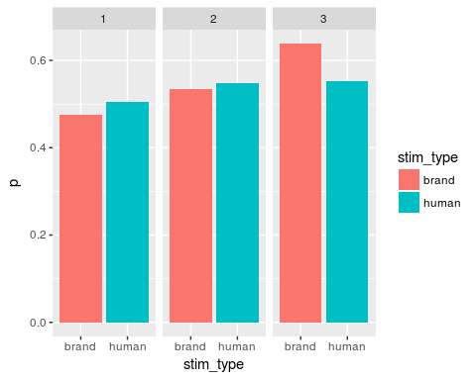

**ANALYSIS**

Acceptance rates were analysed with a logistic mixed effects model in which offer type (£10 or 25£), rating category (binned into 3 categories as specified above) and source (brand or human) were coded as predictors. In order to account for the repeated measures design and allow generalization of results, subjects and items (stimuli, coded as stim1) were introduced as random factors.

########## mixed model  
  
model_trust <- glmer(acceptance ~ offer1 * stim_type_b * (rating1 + rating3) + (offer1 * stim_type_b ||subj_id) + (offer1 || stim1), rat_mod_2, binomial, control=glmerControl(optimizer="bobyqa", optCtrl= list(maxfun=100000)))  
  
summary(model_trust)

## Generalized linear mixed model fit by maximum likelihood (Laplace  
## Approximation) [glmerMod]  
## Family: binomial ( logit )  
## Formula:   
## acceptance ~ offer1 * stim_type_b * (rating1 + rating3) + (offer1 *   
## stim_type_b || subj_id) + (offer1 || stim1)  
## Data: rat_mod_2  
## Control:   
## glmerControl(optimizer = "bobyqa", optCtrl = list(maxfun = 1e+05))  
##   
## AIC BIC logLik deviance df.resid   
## 2048.7 2157.4 -1006.4 2012.7 3082   
##   
## Scaled residuals:   
## Min 1Q Median 3Q Max   
## -4.2423 -0.2699 -0.0897 0.2012 8.7622   
##   
## Random effects:  
## Groups Name Variance Std.Dev.  
## stim1 offer1 0.06916 0.2630   
## stim1.1 (Intercept) 0.07339 0.2709   
## subj_id offer1:stim_type_b 0.29276 0.5411   
## subj_id.1 stim_type_b 1.54606 1.2434   
## subj_id.2 offer1 6.03432 2.4565   
## subj_id.3 (Intercept) 9.02378 3.0040   
## Number of obs: 3100, groups: stim1, 50; subj_id, 31  
##   
## Fixed effects:  
## Estimate Std. Error z value Pr(>|z|)   
## (Intercept) -1.49150 0.56423 -2.643 0.00821 **   
## offer1 -3.60408 0.54005 -6.674 2.5e-11 ***  
## stim_type_b 0.45291 0.31896 1.420 0.15562   
## rating1 -0.37115 0.19589 -1.895 0.05813 .   
## rating3 0.37231 0.17718 2.101 0.03561 *   
## offer1:stim_type_b -0.33390 0.44875 -0.744 0.45684   
## offer1:rating1 0.61016 0.37681 1.619 0.10539   
## offer1:rating3 0.13656 0.34299 0.398 0.69052   
## stim_type_b:rating1 -0.06372 0.39273 -0.162 0.87110   
## stim_type_b:rating3 -0.13835 0.35213 -0.393 0.69439   
## offer1:stim_type_b:rating1 -1.17128 0.75895 -1.543 0.12276   
## offer1:stim_type_b:rating3 -0.92082 0.67453 -1.365 0.17221   
## ---  
## Signif. codes: 0 '***' 0.001 '**' 0.01 '*' 0.05 '.' 0.1 ' ' 1  
##   
## Correlation of Fixed Effects:  
## (Intr) offer1 stm_t_ ratng1 ratng3 of1:__ off1:1 off1:3 st__:1  
## offer1 0.070   
## stim_type_b -0.010 -0.027   
## rating1 0.082 0.075 0.060   
## rating3 0.068 0.039 -0.067 0.339   
## offr1:stm__ -0.012 0.002 0.234 0.027 -0.029   
## offr1:rtng1 0.038 0.180 0.011 0.390 0.161 0.098   
## offr1:rtng3 0.017 0.141 -0.032 0.163 0.361 -0.099 0.371   
## stm_typ_b:1 0.014 0.010 0.326 0.165 0.012 0.203 0.004 -0.014   
## stm_typ_b:3 -0.013 0.000 0.246 0.019 -0.044 0.103 -0.004 -0.062 0.358  
## offr1:s__:1 0.005 0.032 0.141 0.001 -0.012 0.505 0.135 0.005 0.399  
## offr1:s__:3 -0.004 -0.017 0.062 0.007 -0.065 0.368 0.027 -0.070 0.173  
## st__:3 o1:__:1  
## offer1   
## stim_type_b   
## rating1   
## rating3   
## offr1:stm__   
## offr1:rtng1   
## offr1:rtng3   
## stm_typ_b:1   
## stm_typ_b:3   
## offr1:s__:1 0.169   
## offr1:s__:3 0.363 0.394

mod_trust2 <- update(model_trust, . ~ . -offer1)  
anova(model_trust, mod_trust2) # test main effect of first factor

## Data: rat_mod_2  
## Models:  
## mod_trust2: acceptance ~ stim_type_b + rating1 + rating3 + (offer1 * stim_type_b ||   
## mod_trust2: subj_id) + (offer1 || stim1) + offer1:stim_type_b + offer1:rating1 +   
## mod_trust2: offer1:rating3 + stim_type_b:rating1 + stim_type_b:rating3 +   
## mod_trust2: offer1:stim_type_b:rating1 + offer1:stim_type_b:rating3  
## model_trust: acceptance ~ offer1 * stim_type_b * (rating1 + rating3) + (offer1 *   
## model_trust: stim_type_b || subj_id) + (offer1 || stim1)  
## Df AIC BIC logLik deviance Chisq Chi Df Pr(>Chisq)   
## mod_trust2 17 2076.5 2179.2 -1021.2 2042.5   
## model_trust 18 2048.7 2157.4 -1006.4 2012.7 29.763 1 4.883e-08 ***  
## ---  
## Signif. codes: 0 '***' 0.001 '**' 0.01 '*' 0.05 '.' 0.1 ' ' 1

mod_trust3 <- update(model_trust, . ~ . -stim_type_b)  
anova(model_trust, mod_trust3) # test main effect of second factor

## Data: rat_mod_2  
## Models:  
## mod_trust3: acceptance ~ offer1 + rating1 + rating3 + (offer1 * stim_type_b ||   
## mod_trust3: subj_id) + (offer1 || stim1) + offer1:stim_type_b + offer1:rating1 +   
## mod_trust3: offer1:rating3 + stim_type_b:rating1 + stim_type_b:rating3 +   
## mod_trust3: offer1:stim_type_b:rating1 + offer1:stim_type_b:rating3  
## model_trust: acceptance ~ offer1 * stim_type_b * (rating1 + rating3) + (offer1 *   
## model_trust: stim_type_b || subj_id) + (offer1 || stim1)  
## Df AIC BIC logLik deviance Chisq Chi Df Pr(>Chisq)  
## mod_trust3 17 2048.7 2151.4 -1007.4 2014.7   
## model_trust 18 2048.7 2157.4 -1006.4 2012.7 1.9657 1 0.1609

mod_trust4 <- update(model_trust, .~ . -rating1 -rating3)  
anova(model_trust, mod_trust4) ## test main effect of third factor

## Data: rat_mod_2  
## Models:  
## mod_trust4: acceptance ~ offer1 + stim_type_b + (offer1 * stim_type_b ||   
## mod_trust4: subj_id) + (offer1 || stim1) + offer1:stim_type_b + offer1:rating1 +   
## mod_trust4: offer1:rating3 + stim_type_b:rating1 + stim_type_b:rating3 +   
## mod_trust4: offer1:stim_type_b:rating1 + offer1:stim_type_b:rating3  
## model_trust: acceptance ~ offer1 * stim_type_b * (rating1 + rating3) + (offer1 *   
## model_trust: stim_type_b || subj_id) + (offer1 || stim1)  
## Df AIC BIC logLik deviance Chisq Chi Df Pr(>Chisq)   
## mod_trust4 16 2056.8 2153.4 -1012.4 2024.8   
## model_trust 18 2048.7 2157.4 -1006.4 2012.7 12.031 2 0.002441 **  
## ---  
## Signif. codes: 0 '***' 0.001 '**' 0.01 '*' 0.05 '.' 0.1 ' ' 1

mod_trust_inter <- update(model_trust, . ~ . -offer1:stim_type_b - offer1:rating1 - offer1:rating3 - stim_type_b:rating1 - stim_type_b:rating3)  
anova(model_trust, mod_trust_inter) # test interaction

## Data: rat_mod_2  
## Models:  
## mod_trust_inter: acceptance ~ offer1 + stim_type_b + rating1 + rating3 + (offer1 *   
## mod_trust_inter: stim_type_b || subj_id) + (offer1 || stim1) + offer1:stim_type_b:rating1 +   
## mod_trust_inter: offer1:stim_type_b:rating3  
## model_trust: acceptance ~ offer1 * stim_type_b * (rating1 + rating3) + (offer1 *   
## model_trust: stim_type_b || subj_id) + (offer1 || stim1)  
## Df AIC BIC logLik deviance Chisq Chi Df Pr(>Chisq)  
## mod_trust_inter 13 2042.3 2120.8 -1008.2 2016.3   
## model_trust 18 2048.7 2157.4 -1006.4 2012.7 3.5717 5 0.6126

mod_new <- glmer(acceptance ~ (rating1 + rating3) * stim_type_b + (stim_type_b || subj_id), rat_mod_2, binomial, control=glmerControl(optimizer="bobyqa", optCtrl= list(maxfun=100000)))  
  
summary(mod_new)

## Generalized linear mixed model fit by maximum likelihood (Laplace  
## Approximation) [glmerMod]  
## Family: binomial ( logit )  
## Formula: acceptance ~ (rating1 + rating3) * stim_type_b + (stim_type_b ||   
## subj_id)  
## Data: rat_mod_2  
## Control:   
## glmerControl(optimizer = "bobyqa", optCtrl = list(maxfun = 1e+05))  
##   
## AIC BIC logLik deviance df.resid   
## 3035.7 3084.0 -1509.8 3019.7 3092   
##   
## Scaled residuals:   
## Min 1Q Median 3Q Max   
## -5.6759 -0.6544 -0.1502 0.6199 7.1634   
##   
## Random effects:  
## Groups Name Variance Std.Dev.  
## subj_id (Intercept) 5.0070 2.2376   
## subj_id.1 stim_type_b 0.4034 0.6351   
## Number of obs: 3100, groups: subj_id, 31  
##   
## Fixed effects:  
## Estimate Std. Error z value Pr(>|z|)   
## (Intercept) -0.96951 0.41161 -2.355 0.01850 *   
## rating1 -0.34299 0.13294 -2.580 0.00988 **  
## rating3 0.19100 0.11591 1.648 0.09940 .   
## stim_type_b 0.25268 0.17726 1.426 0.15402   
## rating1:stim_type_b 0.11839 0.26746 0.443 0.65801   
## rating3:stim_type_b 0.03667 0.23131 0.159 0.87402   
## ---  
## Signif. codes: 0 '***' 0.001 '**' 0.01 '*' 0.05 '.' 0.1 ' ' 1  
##   
## Correlation of Fixed Effects:  
## (Intr) ratng1 ratng3 stm_t_ rt1:__  
## rating1 0.080   
## rating3 0.070 0.363   
## stim_type_b -0.004 0.110 -0.094   
## rtng1:stm__ 0.013 0.271 0.031 0.433   
## rtng3:stm__ -0.016 0.042 -0.018 0.319 0.362

**Interpretation**

There was no main effect of source, $χ^{2}(1)$ = 2.54, p = .110. As predicted from the graph, there was however a main effect of rating of trustworthiness, $χ^{2}(2)$ = 12.031, p < .001, meaning that differences in ratings predicted differences in acceptance rates. Specifically, higher ratings were associated with increased acceptance.

Analysis of the interaction between ratings of trustworthiness and source type were non significant, suggesting that at equal ratings predict similar patterns of acceptance for both human and brands offer.

SECOND PART, **REACTION TIMES**.

I created a data_frame and summarised the reaction times grouping by subjects, stimulus type and kind of offer.

ultim_RT <- ultimatum %>%  
 group_by(subj_id, stim_type, offer) %>%  
 summarise(mean_rt = mean(RT), mean_p = mean(acceptance))   
  
violinplot <- ggplot(ultim_RT, aes(offer, mean_rt)) + geom_violin()  
print(violinplot)

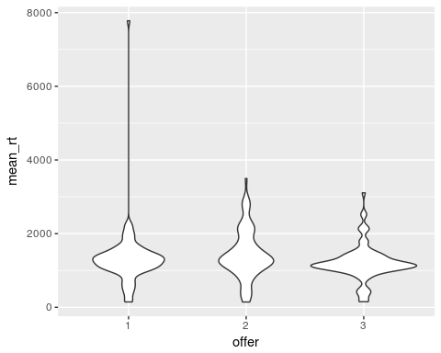

col_plot_rt <- ggplot(ultim_RT, aes(x = offer, y = mean_rt, fill = offer)) + geom_col() + facet_grid(~stim_type)  
  
hist <- hist(ultim_RT$mean_rt, breaks = 30, main = "distribution with outliers")

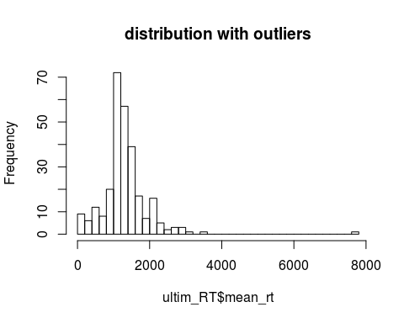

The distribution of the mean reaction times is visualised with a violin_plot split by offer type, while overall distribution is presented in the histogram below. It is possible to notice the presence of outliers which will be removed before continuing with the analysis.

outliers <- ggplot(ultim_RT, aes(offer, mean_rt)) + geom_boxplot() + ggtitle("Mean Reaction Times With Outliers")  
  
rem_outlier_rt <- ultim_RT %>%  
 filter(mean_rt < 6000)  
  
rem_outliers <- ggplot(rem_outlier_rt, aes(offer, mean_rt)) + geom_boxplot() + ggtitle("Mean Reaction Times Without Outliers")  
  
###### extra graph  
  
col_plot_no_out <- ggplot(rem_outlier_rt, aes(x = offer, y = mean_rt, fill = offer)) + geom_col() + facet_grid(~stim_type)

The distribution without the outliers is presented in the figures below and looks closer to a normal distribution.

hist_no_out <- hist(rem_outlier_rt$mean_rt, breaks = 30, main ="distribution without outliers")

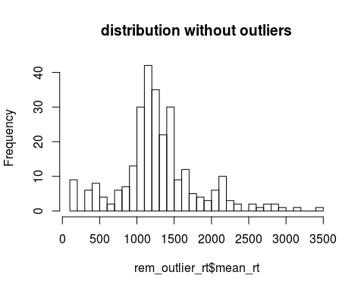

violinplot_no_out <- ggplot(rem_outlier_rt, aes(offer, mean_rt)) + geom_violin()  
print(violinplot_no_out)

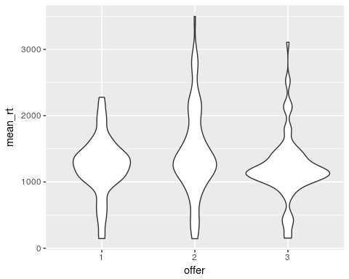

Descriptive statistics are provided in the table below and presented in the bar chart.

plot_rt <- rem_outlier_rt %>%  
 group_by(offer, stim_type) %>%  
 summarise(mean = mean(mean_rt),  
 SD = sd(mean_rt)) %>%  
 select(stim_type, offer, mean, SD) %>%  
 print()

## # A tibble: 9 x 4  
## # Groups: offer [3]  
## stim_type offer mean SD  
## <chr> <chr> <dbl> <dbl>  
## 1 brand 1 1318.724 502.9507  
## 2 computer 1 1177.631 353.2452  
## 3 human 1 1248.923 428.2469  
## 4 brand 2 1478.594 687.3685  
## 5 computer 2 1244.164 473.9095  
## 6 human 2 1563.214 758.5462  
## 7 brand 3 1233.524 482.2584  
## 8 computer 3 1114.134 347.1129  
## 9 human 3 1269.286 576.3329

plot__ <- ggplot(plot_rt, aes(x = offer, y = mean, fill = offer)) + geom_col() + facet_grid(~stim_type)  
  
print(plot__)

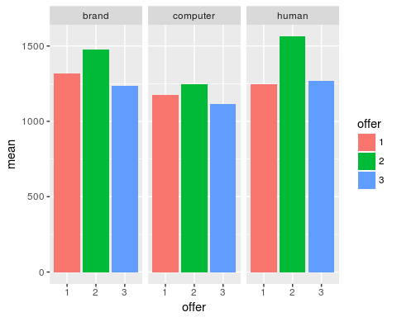

The bar plot shows that intensity of the offer (highest fairness and highess unfairness (offer 1 and 3) are associated as expected with shorter reaction times as compared to the highest uncertainty condition simulated with offer2 (25/75 split). This relationship was analysed with a repeated measures analysis of variance

#### recoding   
  
ultim_RT_recode <- rem_outlier_rt %>%   
 mutate(offer_1 = ifelse(offer == "1", .5, -.5),  
 offer_2 = ifelse(offer == "2", .5, -.5),  
 brand = ifelse(stim_type == "brand", .5, -.5),  
 human = ifelse(stim_type == "human", .5, -5))  
   
## mixed model formula   
  
mod_rt <- lmer(mean_rt ~ (offer_1 + offer_2) * (brand + human) + ( (offer_1 + offer_2) * (brand + human)||subj_id), ultim_RT_recode)  
  
summary(mod_rt)

## Linear mixed model fit by REML ['lmerMod']  
## Formula:   
## mean_rt ~ (offer_1 + offer_2) * (brand + human) + ((1 | subj_id) +   
## (0 + offer_1 | subj_id) + (0 + offer_2 | subj_id) + (0 +   
## brand | subj_id) + (0 + human | subj_id) + (0 + offer_1:brand |   
## subj_id) + (0 + offer_1:human | subj_id) + (0 + offer_2:brand |   
## subj_id) + (0 + offer_2:human | subj_id))  
## Data: ultim_RT_recode  
##   
## REML criterion at convergence: 3955.7  
##   
## Scaled residuals:   
## Min 1Q Median 3Q Max   
## -3.1407 -0.4960 -0.0780 0.3228 3.4181   
##   
## Random effects:  
## Groups Name Variance Std.Dev.   
## subj_id (Intercept) 2.281e+05 4.776e+02  
## subj_id.1 offer_1 2.327e+04 1.526e+02  
## subj_id.2 offer_2 7.728e+04 2.780e+02  
## subj_id.3 brand 2.306e-10 1.519e-05  
## subj_id.4 human 8.329e+02 2.886e+01  
## subj_id.5 offer_1:brand 0.000e+00 0.000e+00  
## subj_id.6 offer_1:human 4.588e+02 2.142e+01  
## subj_id.7 offer_2:brand 0.000e+00 0.000e+00  
## subj_id.8 offer_2:human 0.000e+00 0.000e+00  
## Residual 6.255e+04 2.501e+02  
## Number of obs: 278, groups: subj_id, 31  
##   
## Fixed effects:  
## Estimate Std. Error t value  
## (Intercept) 1481.892 92.831 15.963  
## offer_1 -2.516 76.112 -0.033  
## offer_2 336.548 86.672 3.883  
## brand 187.134 45.175 4.142  
## human 35.486 9.673 3.668  
## offer_1:brand 20.448 90.350 0.226  
## offer_1:human -15.247 16.781 -0.909  
## offer_2:brand 115.040 89.838 1.281  
## offer_2:human 29.800 16.334 1.824  
##   
## Correlation of Fixed Effects:  
## (Intr) offr_1 offr_2 brand human offr_1:b offr_1:h offr_2:b  
## offer_1 0.179   
## offer_2 0.156 0.380   
## brand 0.221 0.273 0.234   
## human 0.269 0.328 0.288 0.420   
## offr_1:brnd 0.112 0.540 0.234 0.506 0.210   
## offer_1:hmn 0.155 0.757 0.332 0.242 0.411 0.484   
## offr_2:brnd 0.110 0.268 0.471 0.497 0.211 0.497 0.243   
## offer_2:hmn 0.159 0.389 0.683 0.249 0.422 0.249 0.487 0.500

##likelihood ratio tests   
  
rt_offer_mod <- update(mod_rt, . ~ . -offer_1 -offer_2)  
anova(mod_rt, rt_offer_mod) # test main effect of first factor

## refitting model(s) with ML (instead of REML)

## Data: ultim_RT_recode  
## Models:  
## rt_offer_mod: mean_rt ~ brand + human + (1 | subj_id) + (0 + offer_1 | subj_id) +   
## rt_offer_mod: (0 + offer_2 | subj_id) + (0 + brand | subj_id) + (0 + human |   
## rt_offer_mod: subj_id) + (0 + offer_1:brand | subj_id) + (0 + offer_1:human |   
## rt_offer_mod: subj_id) + (0 + offer_2:brand | subj_id) + (0 + offer_2:human |   
## rt_offer_mod: subj_id) + offer_1:brand + offer_1:human + offer_2:brand +   
## rt_offer_mod: offer_2:human  
## mod_rt: mean_rt ~ (offer_1 + offer_2) * (brand + human) + ((1 | subj_id) +   
## mod_rt: (0 + offer_1 | subj_id) + (0 + offer_2 | subj_id) + (0 +   
## mod_rt: brand | subj_id) + (0 + human | subj_id) + (0 + offer_1:brand |   
## mod_rt: subj_id) + (0 + offer_1:human | subj_id) + (0 + offer_2:brand |   
## mod_rt: subj_id) + (0 + offer_2:human | subj_id))  
## Df AIC BIC logLik deviance Chisq Chi Df Pr(>Chisq)  
## rt_offer_mod 17 4086.8 4148.5 -2026.4 4052.8   
## mod_rt 19 4074.4 4143.3 -2018.2 4036.4 16.454 2 0.0002673  
##   
## rt_offer_mod   
## mod_rt ***  
## ---  
## Signif. codes: 0 '***' 0.001 '**' 0.01 '*' 0.05 '.' 0.1 ' ' 1

rt_stim_mod <- update(mod_rt, . ~ . -brand - human)  
anova(mod_rt, rt_stim_mod) # test main effect of second factor

## refitting model(s) with ML (instead of REML)

## Data: ultim_RT_recode  
## Models:  
## rt_stim_mod: mean_rt ~ offer_1 + offer_2 + (1 | subj_id) + (0 + offer_1 |   
## rt_stim_mod: subj_id) + (0 + offer_2 | subj_id) + (0 + brand | subj_id) +   
## rt_stim_mod: (0 + human | subj_id) + (0 + offer_1:brand | subj_id) + (0 +   
## rt_stim_mod: offer_1:human | subj_id) + (0 + offer_2:brand | subj_id) +   
## rt_stim_mod: (0 + offer_2:human | subj_id) + offer_1:brand + offer_1:human +   
## rt_stim_mod: offer_2:brand + offer_2:human  
## mod_rt: mean_rt ~ (offer_1 + offer_2) * (brand + human) + ((1 | subj_id) +   
## mod_rt: (0 + offer_1 | subj_id) + (0 + offer_2 | subj_id) + (0 +   
## mod_rt: brand | subj_id) + (0 + human | subj_id) + (0 + offer_1:brand |   
## mod_rt: subj_id) + (0 + offer_1:human | subj_id) + (0 + offer_2:brand |   
## mod_rt: subj_id) + (0 + offer_2:human | subj_id))  
## Df AIC BIC logLik deviance Chisq Chi Df Pr(>Chisq)   
## rt_stim_mod 17 4091.3 4153.0 -2028.7 4057.3   
## mod_rt 19 4074.4 4143.3 -2018.2 4036.4 20.939 2 2.838e-05 ***  
## ---  
## Signif. codes: 0 '***' 0.001 '**' 0.01 '*' 0.05 '.' 0.1 ' ' 1

rt_interaction_mod <- update(mod_rt, . ~ . -offer_1:brand - offer_1:human - offer_2:brand - offer_2:human)  
anova(mod_rt, rt_interaction_mod) # test interaction

## refitting model(s) with ML (instead of REML)

## Data: ultim_RT_recode  
## Models:  
## rt_interaction_mod: mean_rt ~ offer_1 + offer_2 + brand + human + (1 | subj_id) +   
## rt_interaction_mod: (0 + offer_1 | subj_id) + (0 + offer_2 | subj_id) + (0 +   
## rt_interaction_mod: brand | subj_id) + (0 + human | subj_id) + (0 + offer_1:brand |   
## rt_interaction_mod: subj_id) + (0 + offer_1:human | subj_id) + (0 + offer_2:brand |   
## rt_interaction_mod: subj_id) + (0 + offer_2:human | subj_id)  
## mod_rt: mean_rt ~ (offer_1 + offer_2) * (brand + human) + ((1 | subj_id) +   
## mod_rt: (0 + offer_1 | subj_id) + (0 + offer_2 | subj_id) + (0 +   
## mod_rt: brand | subj_id) + (0 + human | subj_id) + (0 + offer_1:brand |   
## mod_rt: subj_id) + (0 + offer_1:human | subj_id) + (0 + offer_2:brand |   
## mod_rt: subj_id) + (0 + offer_2:human | subj_id))  
## Df AIC BIC logLik deviance Chisq Chi Df  
## rt_interaction_mod 15 4074.5 4128.9 -2022.2 4044.5   
## mod_rt 19 4074.4 4143.3 -2018.2 4036.4 8.0866 4  
## Pr(>Chisq)   
## rt_interaction_mod   
## mod_rt 0.08846 .  
## ---  
## Signif. codes: 0 '***' 0.001 '**' 0.01 '*' 0.05 '.' 0.1 ' ' 1

The analysis showed a main effect of offer, such that offer1 and offer2 significantly differed in the acceptance reaction times as compared to offer3, set as baseline measure. Specifically, offers in the most uncertain condition (£25) were accepted slower than offers in the other categories.

However, no significant interaction was found between the factors.

options(contrasts = c("contr.sum","contr.poly"))  
  
mod_rt <- aov(mean_rt ~ stim_type*offer + Error(subj_id), ultim_RT_recode)  
summary(mod_rt)

##   
## Error: subj_id  
## Df Sum Sq Mean Sq  
## stim_type 1 4024121 4024121  
##   
## Error: Within  
## Df Sum Sq Mean Sq F value Pr(>F)   
## stim_type 2 1892360 946180 3.557 0.02986 *   
## offer 2 2591638 1295819 4.872 0.00835 **  
## stim_type:offer 4 540344 135086 0.508 0.72997   
## Residuals 268 71279441 265968   
## ---  
## Signif. codes: 0 '***' 0.001 '**' 0.01 '*' 0.05 '.' 0.1 ' ' 1

The anova yielded results similar to the mixed models regression by finding a main effect of source type and offer, and no effect of the interaction of the factors.